Course: CS420 - Artificial Intelligence

02 – Adversarial Search

Question 1. Consider the game search tree shown below, in which a square denotes MAX’s move and a circle for MIN’s move.
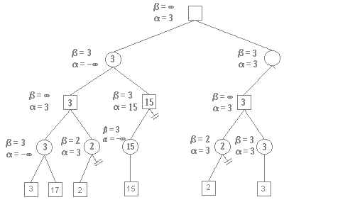
Note the minimax value for each node of the tree using Minimax algorithm without pruning.
Then, show where alpha-beta pruning occurs by crossing out corresponding branches. Briefly explain each case.

Question 2. Consider the following game tree.
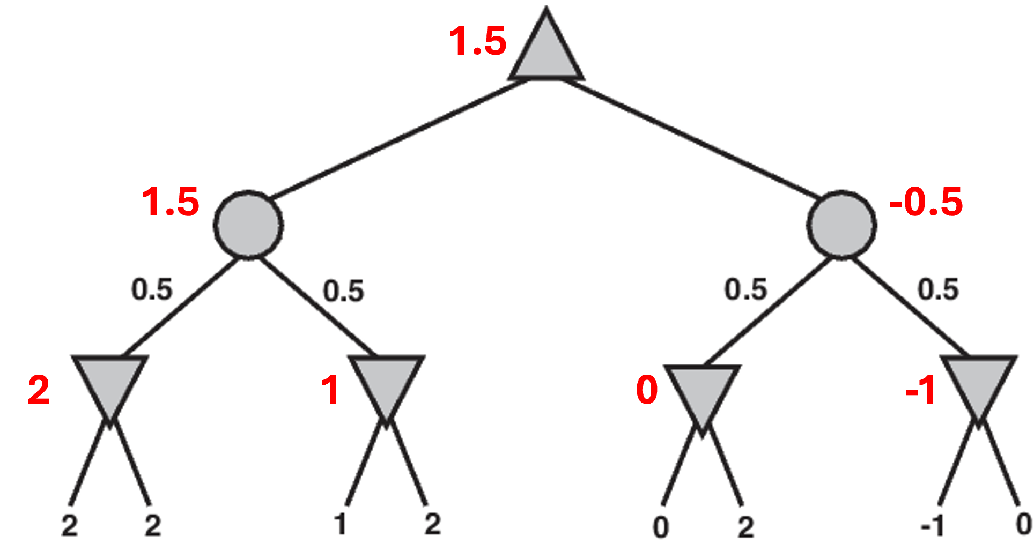
The expectimax values are noted aside the nodes.
Now assume that the value at each node is at most 2. Identify and mark any branches that can be pruned, and provide an explanation for each pruned branch.
The right subtree of the right chance node can be pruned. At the right chance node, the value rolled back from the left child (which is a min node) is 0. Even when the value from the right child (which is another min node) is maximum (i.e., 2), the right chance node only gets a value of 1.

Question 3. Consider the following game tree. Calculate the UCB1 values for the nodes in the tree using the formula given in the lecture) with C = 2.
Assume that a roll-out is performed on the given tree, resulting in a value of 20. Please update the statistics for the corresponding nodes in the tree.
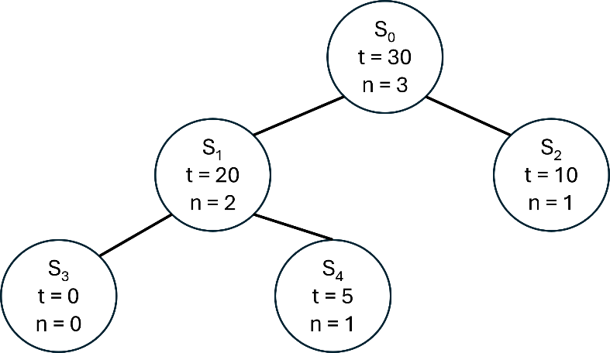
From S₀, evaluate S₁ and S₂
$S_{1}=20+2\sqrt{\frac{ln⁡(3)}{2}}=21.482$ $S_{2}=10+2\sqrt{\frac{ln⁡(3)}{1}}=12.096$ Thus, choose S₁

From S₁, evaluate S₃ and S₄
$S_{3}=+∞$ $S_{4}=5+2\sqrt{\frac{ln⁡(2)}{1}}=6.665$ Thus, choose S₃

Update the value 20 for all the nodes on the path.
